Jesse Brown
April 6, 1889 – December 7, 1955

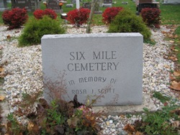
Photo by Barbara Baker Anderson

Indiana, U.S., Death Certificates, 1899-2011

Name: Jesse Brown
Gender: Male
Race: White
Age: 66
Marital status: Widowed
Birth Date: 6 Apr 1889
Birth Place: Ind
Death Date: 7 Dec 1955, burned in home fire
Death Place: Bluffton, Wells, Indiana, USA
Father: Soloman Brown
Mother: Hannah Haflich
Informant: Warren McBride, Bluffton
Burial: 12-8-1955 Six Mile Cem.

