Emanuel Mathias Brinneman
September 8, 1871 – July 2, 1941

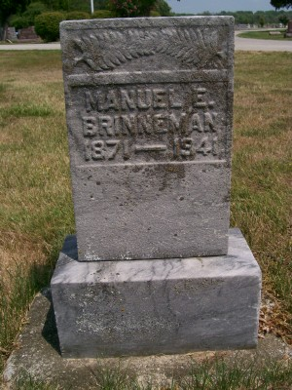
Photo by Scott Shoup

Indiana, U.S., Death Certificates, 1899-2011

Name: Emanuel M Brinneman
Gender: Male
Race: White
Age: 69y 9m 24d
Marital status: Married
Birth Date: 8 Sep 1871
Birth Place: Wells Co Ind
Death Date: 2 Jul 1941, ruptured appendix
Death Place: Bluffton, Wells, Indiana, USA
Father: Jefferson Brinneman
Mother: Susan Glass
Spouse: Annie Reed Kemp, age 65
Informant: Mrs. E. M. Brinneman
Burial: 7-3-1941 Six Mile Cem

