John Edward Bradley
October 29, 1960 – March 12, 1983

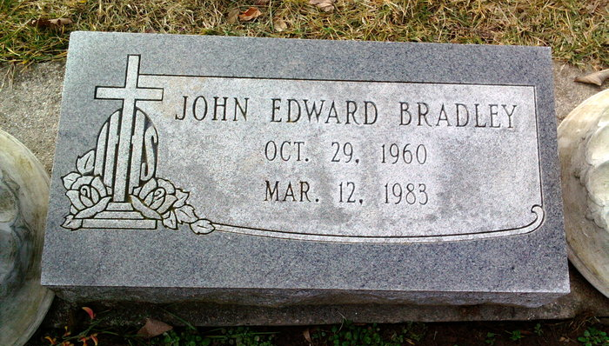
Photo by Scott Shoup

Indiana, U.S., Death Certificates, 1899-2011

Name: John Edward Bradley
Gender: Male
Race: Caucasian (White)
Age: 22
Marital status: Single
Birth Date: 29 Oct 1960
Birth Place: Indiana
Death Date: 12 Mar 1983
Death Place: Bluffton, Wells, Indiana, USA
Father: Louis Bradley
Mother: Ruth Newsom
Informant: Dr. Louis Bradley, father
Burial: Six Mile Cemetery 3-15-1983

