Kenneth A. Bowman
May 13, 1909 – December 14, 1985

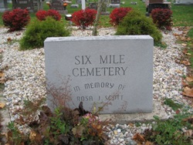
Photo by Barbara Baker Anderson

Indiana, U.S., Death Certificates, 1899-2011

Name: Kenneth A Bowman
Gender: Male
Race: White
Age: 76
Marital status: Widowed
Military service
Birth Date: 13 May 1909
Birth Place: Indiana
Death Date: 14 Dec 1985
Death Place: Bluffton, Wells, Indiana, USA
Father: Edward Bowman
Mother: Jessie Roy
Informant: Ronald Bowman (son), Bluffton
Burial: Six Mile 12/17/1985

