Jane Ann Bowman
July 2, 1958 – December 31, 1958

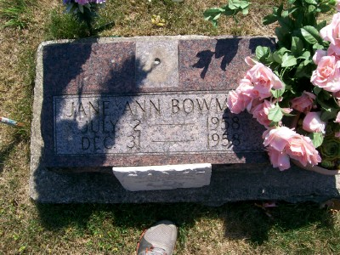
Photo by Scott Shoup

Indiana, U.S., Death Certificates, 1899-2011

Name: Jane Ann Bowman
Gender: Female
Race: White
Age: 5m 29d
Birth Date: 2 Jul 1958
Birth Place: Indiana
Death Date: 31 Dec 1958
Death Place: Bluffton, Wells, Indiana, USA
Father: George O Bowman, informant
Mother: Phyllis Betz
Burial: January 2, 1959 Six Mile

