Adam Bowman
September 3, 1825 – September 25, 1916

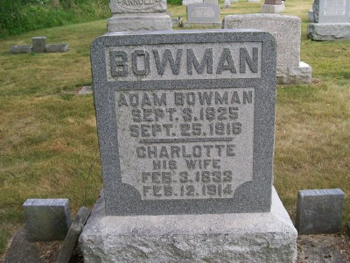
Photo by Scott Shoup

Indiana, U.S., Death Certificates, 1899-2011

Name: Adam Bouman
[Adam Bowman]
Gender: Male
Race: White
Age: 91
Marital status: Widowed
Birth Date: 3 Sep 1825
Birth Place: Stark Co O.
Death Date: 25 Sep 1916
Death Place: Hartford City, Blackford, Indiana, USA
Father: Adam Bowman
Mother: Elizabeth Bouman
Spouse: Charlotte Shick Bouman
Informant: too faded to read
Burial: faded 9-27-1916

