Abbie (Studabaker) Bowman
November 28, 1861 – March 27, 1950

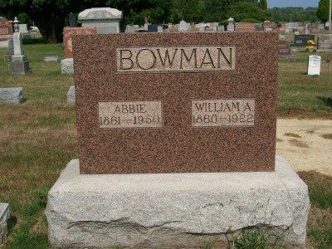
Photo by Scott Shoup

Indiana, U.S., Death Certificates, 1899-2011

Name: Abbie Bowman
[Abbie Studabaker]
Gender: Female
Race: White
Age: 88y 3m 29d
Marital status: Widowed
Birth Date: 28 Nov 1861
Birth Place: Wells County Indiana
Death Date: 27 Mar 1950
Death Place: Bluffton, Wells, Indiana, USA
Father: Abraham Studabaker
Mother: left blank
Informant: Mrs. Orval Barger, Craigville
Burial: 3/29/1950 Six Mile Cemetery

