Olen Bossert
March 14, 1909 – May 25, 1983

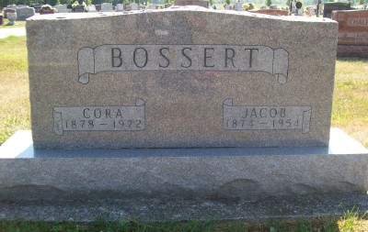
Photo by Scott Shoup

Indiana, U.S., Death Certificates, 1899-2011
Name: Olen Bossert
Gender: Male
Race: White
Age: 74
Birth Date: 14 Mar 1909
Birth Place: Indiana
Death Date: 25 May 1983
Death Place: Bluffton, Wells, Indiana, USA
Father: Jacob Bossert
Mother: Cora Gentis
Informant: Brice Bauserman, Adm., First Bank of Berne
Burial: Six Mile Cemetery May 27, 1983

