Bertha May (Studabaker) Books
July 10, 1898 – March 24, 1922

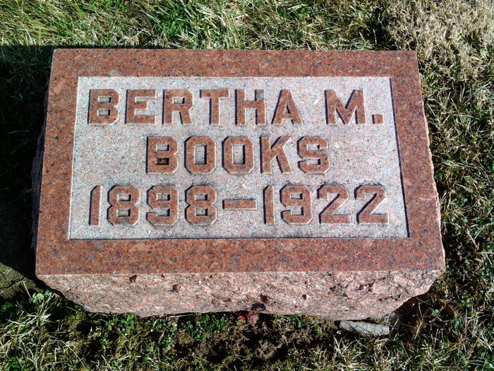
Photo by Thomas Liby

Indiana, U.S., Death Certificates, 1899-2011

Name: Mrs Bertha May Books
[Mrs Bertha May Studabaker]
Gender: Female
Race: White
Age: 23y 8m 14d
Marital status: Married
Birth Date: 10 Jul 1898
Birth Place: Wells Co Ind
Death Date: 24 Mar 1922
Death Place: Bluffton, Wells, Indiana, USA
Father: Frank Studabaker
Mother: Ida Beeler
Spouse: Ray Books, informant
Burial: Six Mile 3/26/1922

