Herbert Booher

June 18, 1900 – November 28, 1989

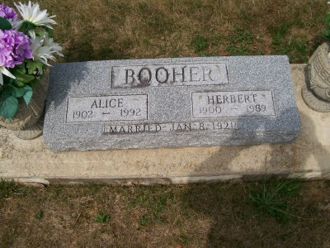

Photo by Scott Shoup

Herbert Booher, 89, Resident of Bluffton, Dies; Services Friday

A resident of 909 south Marion St., Bluffton, Herbert Booher, 89, died at 11 a.m. Tuesday at Caylor-Nickel Medical Center. Death, which followed an illness of three years, was due to pneumonia.

Born June 18, 1900 in Adams County, he was a son of John and Clara Steed Booher. His marriage to the former Alice R. Rowe, who survives, took place Jan. 8, 1920 in Montpelier.

Mr. Booher retired in 1962 after working 35 years as a concrete contractor. He was a World War I veteran, and a member of the first Church of Christ and American Legion.

In addition to the wife, survivors include one son, William H. Booher of Bluffton; three daughters, Mrs. Grant (Imogene) Lindsey of rural Geneva, Mrs. Melvin (Charlotte) Gooley of Huntington, and Mrs. Max (Violet) Helms of Goliad, Texas; 15 grandchildren, 24 great-grandchildren and two great-great-grandchildren.

Friends may call after 1 p.m. Thursday at Thoma-Rich Funeral Home, where services will be conducted by Rev.Larry Sprinkle at 11 a.m. Friday. Burial will follow in Six Mile Cemetery, with American Legion Post 111 in charge of graveside services.

Bluffton News Banner, Wells County, Indiana

Wednesday, November 29, 1989