Alice Mae (Rowe) Booher
October 22, 1902 – November 12, 1992

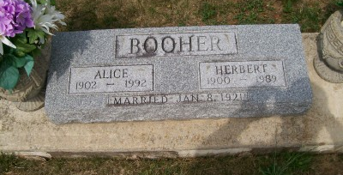
Photo by Scott Shoup

Alice Booher Dies at Age 90; Services to Be on Saturday

Mrs. Alice C. Booher, 90, widow of Herbert Booher, died at 6 a.m. today at Caylor-Nickel Hospital.
A former resident of 909 South Marion St., Mrs. Booher had resided the past two years at the Christian Care Center. She had retired in 1966 after several years of employment with Caylor-Nickel Hospital.
Mrs. Booher was born in Wells County Oct. 22, 1902, a daughter of John C. and Ella Moon Rowe. Her marriage at Montpelier on Jan. 8, 1920 was to Herbert Booher, who died in November 1989.
She was a member of the First Church of Christ and a past president of American Legion Post III Auxiliary.
Surviving are three daughters, Mrs. Grant (Imogene) Lindsey of Geneva Route 2, Mrs. Melvin (Charlotte) Gooley of Huntington and Mrs. Max (Violet) Helms of Goliad, Texas; one son, William H. Booher of Bluffton; 14 grandchildren and 29 great-grandchildren.
Calling will be from 1 to 9 p.m. Friday at the Thoma/Rich Funeral Home, where services will be at 10:30 a.m. Saturday with Rev. Larry Sprinkle officiating. Burial will be in Six Mile Cemetery.
Preferred are memorials to the First Church of Christ.

Bluffton News Banner, Wells County, Indiana
Thursday, November 12, 1992

