Oliver F. Blumenhorst
December 21, 1909 – October 25, 1969

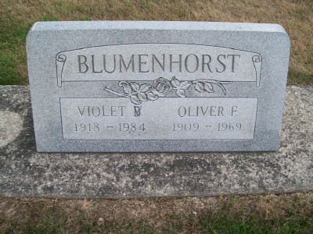
Photo by Scott Shoup

H. Brown & Son Funeral Home record
Blumenhorst, Oliver
Oc. Blacksmith
B. 21 Dec 1909 St. Mary's OH. D. 25 Oct 1969 Wells Co,, IN.
bur. Six Mile Cem. Wells Co.
Fa. Julius Blumenhorst. Mo. Loveta Slife.
M. 25 Feb 1940 Violet Brinneman.
Ch. Ruthann Borne.
Sib. Leroy, Melville & Mrs. W. K. Clapper
*****

Indiana, U.S., Death Certificates, 1899-2011

Name: Oliver F Blumenhorst
Gender: Male
Race: White
Age: 59
Marital status: Married
Birth Date: 21 Dec 1909
Birth Place: Ohio
Death Date: 25 Oct 1969
Death Place: Bluffton, Wells, Indiana, USA
Father: Julius Blumenhorsrt
Mother: Loutta Slife
Spouse: Violet Brinneman
Informant: Mrs. Violet Blumenhorst, wife
Burial: Six Mile Cemetery Oct. 29, 1969

