Clinton L. Bierie
March 5, 1905 – June 3, 1963

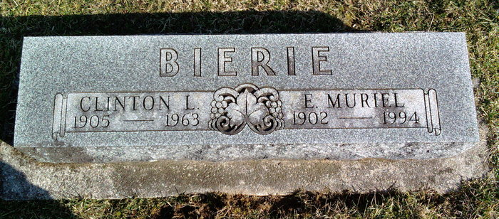
Photo by Thomas Liby
Obit from Janice Vasilovski

Clinton L. Bierie, 58, died at his residence, 1709 Tecumseh Ave., Monday at 5 a.m.
A native of Wells County, he resided in Fort Wayne since 1938.
He was a retired employee of the Howard Sober trucking firm, and a member of Crescent Ave., EUB Church, United Commercial Travelers and the Moose Lodge at Bluffton.
Surviving are his wife, Muriel; a daughter, Mrs. Robert Runyan, Fort Wayne; a sister, Mrs. S. P. Hoffman, Fort Wayne; two grandchildren and one great-grandchild.
Services will be held Thursday at 10 a.m. in D. O. McComb and Sons Funeral Home, the Rev. A Hunter Colpitts officiating, with burial in Bluffton Six Mile Cemetery. Friends may call the funeral home after 7 p.m. today. [Tuesday, June 4, 1963]

Berne (IN) Library Heritage Room Adams County Obits 1962-64, image 24
*****

Indiana, U.S., Death Certificates, 1899-2011
Name: Clinton L Bierie
Gender: Male
Race: White
Age: 58
Marital status: Married
Birth Date: 5 Mar 1905
Birth Place: Indiana
Death Date: 3 Jun 1963
Death Place: Ft Wayne, Allen, Indiana, USA
Father: Eli Bierie
Mother: Elizabeth Beeler
Informant: Mrs. Muriel Bierie; widow; Fort Wayne, Indiana
Burial: June 6, 1963; Six Mile Cemetery; Wells County, Indiana

