Micheal E. Biberstine
October 10, 1904 – October 14, 1974

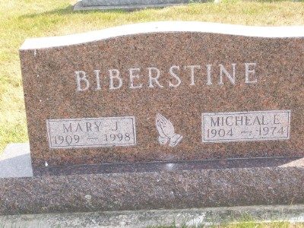
Photo Scott Shoup

Michael E. Biberstine, 70, of Route 2, Warren died today of a
heart attack at his home. A son of David and Mary Moser
Biberstine, he was born October 10, 1904 at Monroe, Indiana. His marriage on June 18, 1950 was to the former Mary Kaufman, who survives.
Also surviving are two brothers, David of Dunkirk and Chris
of Berne and four sisters, Mrs. Martha Garrison of Bluffton,
Mrs. Albert (Goldie) Bauman of Monroe, Mrs. Cleo (Clara)
Hartman and Mrs. Sadie Strahm, both of Berne.
Services will be Wednesday at the Nazarene Church with
Rev. Walter Graeflin officiating; Burial in Six Mile Cemetery
with Thoma/Rich Funeral Home in charge.
Bluffton News-Banner, Wells County, Indiana
October 14, 1974

