Martha R. (Michel) Biberstine
July 3, 1903 – November 21,1983

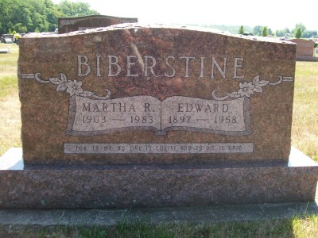
Photo by Scott Shoup

Indiana, U.S., Marriages, 1810-2001

Name: Martha Michel
Gender: Female
Race: White
Age: 16
Event Type: Marriage Registration (Marriage)
Birth Date: 3 Jul 1903
Birth Place: Wells, Indiana
Marriage Date: 2 Feb 1920
Marriage Place: Wells Co, Indiana, United States
Residence Place: Wells, Indiana
Father: Peter Michel
Mother: Mary Ann Ebnit
Spouse: Edward Biberstine
Page: 143
******

U.S., Social Security Death Index, 1935-2014

Name: Martha Biberstine
Social Security Number: xxxx
Birth Date: 3 Jul 1903
Issue Year: 1962
Issue State: Indiana
Last Residence: 46714, Bluffton, Wells, Indiana, USA
Death Date: Nov 1983

