Lloyd W. Biberstine
April 29, 1918 – December 22, 2010

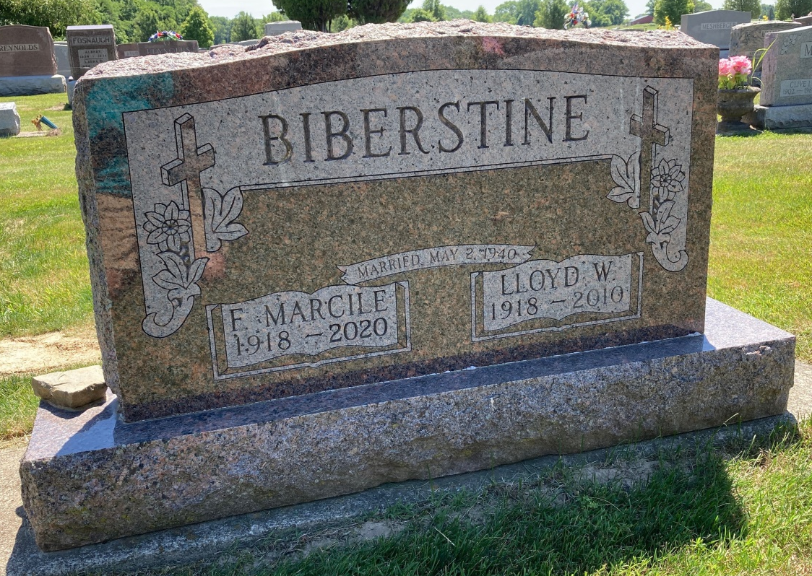
Photo by Scott Shoup

Lloyd W. Biberstine, 92, passed away Wednesday, December 22, 2010 at Christian Care Retirement Community in Bluffton, Indiana Mr. Biberstine was born on April 29th, 1918, in Harrison Township, Wells County, Indiana in the farm home of his parents William and Nora Biberstine. He attended and graduated from Bluffton High School in 1935, and from Ball State Teachers College in 1939. He was married for 70 years to his beloved wife Marcile (Platt) Biberstine , who survives. He is also survived by five children: Richard (Judy) Biberstine of Bluffton, Barbara (Lynn) Burroughs of Ft. Myers, FL, Judy (Roger) Summers of Fort Wayne, Becky (Bob) Gibson of Fort Wayne, William (Renee) Biberstine of Berne; plus 13 grandchildren and 29 great-grandchildren. A sister, Joan Schwartz, resides in Delphos, Oh, and another sister and brother are deceased. While at Ball State, Lloyd was the manager of football, baseball, and basketball, and served as an assistant to Branch McCracken. He was a farmer in earlier years, but primarily he was a lifelong educator, having taught and coached at Rockcreek, Lancaster, Liberty Center, and then serving as principal at Petroleum. In 1961, he became Wells County School Superintendent, which eventually led to the formation of Southern Wells Community Schools, where he served as its first and only school superintendent until 1978 when he retired. Lloyd was deeply connected to the Six Mile Church, where he was a member for 87 years, having joined at the age of five. He was the oldest member of the oldest church in Wells County. Preferred memorials are to the church. Calling hours will be from 2 P.M. – 8 P.M. Sunday, December 26th, 2010 at Thoma/Rich, Chaney and Lemler Funeral Home in Bluffton. Calling is also one hour prior to service Monday at the church. Funeral service is at 11:00 a.m. Monday, December 27th, 2010 at the Six Mile Church with Pastor Ryan Dalrymple officiating. Burial will be at the Six mile Cemetery.

Thomas-Rich, Lemler Funeral Home, Wells County, Indiana

