Frances Marcile (Platt) Biberstine
June 16, 1918 – November 10, 2020

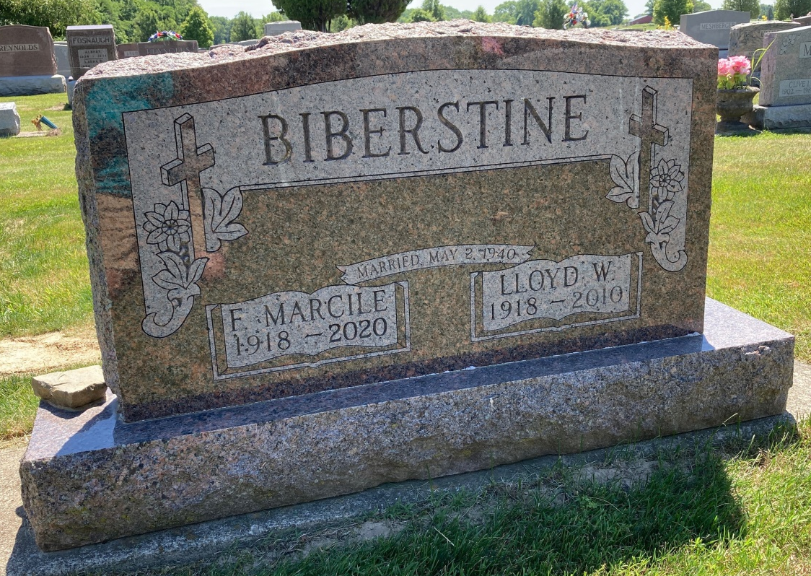
Photo by Scott Shoup

FRANCES MARCILE BIBERSTINE - 102
Marcile Biberstine went to be with her Heavenly Father on Tuesday evening, November 10, 2020. She passed away peacefully at Christian Care Retirement Community in Bluffton, Indiana at the age of 102.
Born on June 16, 1918 in Union Township, Wells County, to Cletus and Dessie Miller Platt, she was married for 70 years to her husband Lloyd Biberstine, who preceded her in death in 2010. She is survived by five children: Richard (Judy) Biberstine of Bluffton, Barbara (Lynn) Burroughs of Ft. Myers, Fl, Judy (Roger) Summers of Fort Wayne, Becky (Bob) Gibson of Fort Wayne, and William (Renee) Biberstine of Decatur; plus 13 grandchildren and 33 great-grandchildren. She is also survived by a sister Edith Harvey of Roanoke. A sister, Gladys Haiflich, and a brother, Darl Platt are deceased.
She attended Liberty Center High School, and later in life also attended Huntington College studying elementary education. She served as a substitute teacher at Adams Central Elementary School. She participated in educational and school activities throughout much of her life. She was also an avid fan of Indiana Hoosier basketball, and the New York Yankees.
Marcile was very proud to be a devoted wife, mother, and homemaker. She demonstrated a life worth celebrating. Her love of cooking always made her the perfect hostess for family and other events. She was a member of the Home Forum Club for many years. She was also active in her lifelong church, Six Mile, where her faithfulness and devotion always showed the commitment of a servant’s heart.
Marcile will be remembered for her dedication to her Lord and her family whom she both deeply loved. With her beautiful spirit, she always thought of others needs before herself. She was a prayer warrior with uncompromising faith. Always soft-spoken, she exhibited unconditional love, and a Christ-like attitude in all that she did. Heaven has gained another angel, and all here are better off for having known her. May her spiritually committed life and her strength of character continue to live on through others.
Due to health concerns at this current time, there will be no public visitation or funeral service. Burial will take place at Six Mile Cemetery in Bluffton. Memorials may be made in Marcile’s name to Christian Care Retirement Community.
Funeral arrangements have been entrusted to the care of the Thoma/Rich, Lemler Funeral Home in Bluffton. Friends can send online condolences to the Biberstine family at www.thomarich.com.

Thomas-Rich, Lemler Funeral Home, Wells County, Indiana

