Alta Biberstine
April 6, 1902 – January 13, 1905

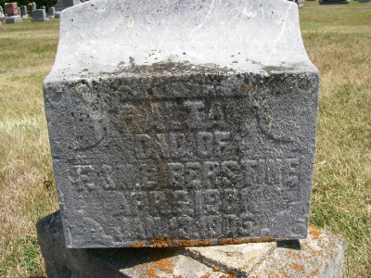
Photo by Scott Shoup

Indiana, Death Certificates, 1899-2011

Name: Alta Biberstine
Gender: Female
Race: White
Age: 3y 9m 7d
Marital status: Child
Birth Date: 6 Apr 1902
Birth Place: Indiana
Death Date: 13 Jan 1905, pneumonia
Death Place: Harrison, Wells, Indiana, USA
Father: Frank Biberstine
Mother: Nettie Durr or Dunn
Informant: Emanuel Biberstine
Burial: Six Mile Cemetery Jan. 15, 1905

