Ivan L. Beer
September 19, 1938 – March 20, 2013

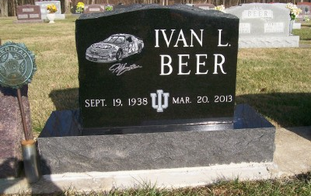
Photos by Scott Shoup

Ivan L. Beer, 74, of Bluffton, died at 5:24 p.m. Wednesday, March 20, 2013, at Ossian Health Care and Rehabilitation.
Mr. Beer had been employed at International Harvester and at the Dallas-Fort Worth International Airport. He had been a truck driver. He was the owner and operator of Ivan's Carpet Cleaning.
He was a 1956 graduate of Bluffton High School and served in the National Guard for 20 years. He was a member of American Legion Post 111 in Bluffton and the Moose Lodge and the Elks Club, both in Bluffton. He was a former member of the St. John United Church of Christ.
He was born Sept. 19, 1938, in Adams County, to Alva "Alvie" Beer and Effie LaTurner Beer.
Survivors include three sons, Kevin Beer, Kent (Tracy) Beer, and Kurt (Angie) Beer, all of Bluffton; two daughters, Lori (Jon) Dobson of Bluffton and Kristin Beer of Tampa, Fla.; nine grandchildren and one great-grandchild; and three sisters, Marlene (George) Schlagenhauf of Bluffton, Janet (Burtis) Moses of Frisco, Texas, and Elaine (Gene) Stoppenhagen of Bluffton. He is also survived by his loyal companion, his dog Mocca.
Services will be held at 7 p.m. Thursday, March 28, at the Goodwin-Cale & Harnish Memorial Chapel, 3220 E. Ind. 124, with Pastor Bruce Holland officiating. Calling will be from 2 to 7 p.m. prior to the service at the funeral home. Burial will be at the Six Mile Cemetery. Military rites will be conducted by members of American Legion Post 111 and the U.S. Honor Guard at the funeral home.
Preferred memorials are to the donor's choice.

Unknown source

