Peter Beeler
February 22, 1843 – January 22, 1900

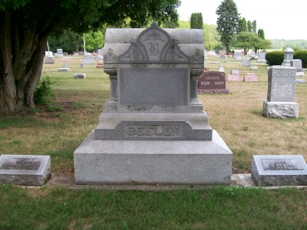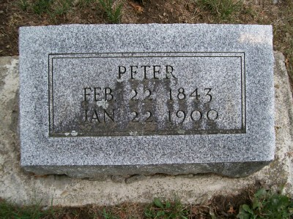
Photos by Scott Shoup

Indiana, U.S., Marriages, 1810-2001

Name: Peter Beeler
Gender: Male
Event Type: Marriage Registration (Marriage)
Marriage Date: 21 Jan 1873
Marriage Place: Indiana, United States
Spouse: Elizabeth Heckathorn
Page: 449
FHL Film Number: 002321470
*****

Indiana, Death Certificates, 1899-2011

Name: Peter Beeler
Gender: Male
Race: White
Age: 56
Marital status: Married
Birth Date: abt 1844
Birth Place: Adams County Ind
Death Date: 22 Jan 1900
Death Place: Bluffton, Wells, Indiana, USA
Father: David Beeler, Switzerland
Mother: Catherine Cooper, Germany
Informant: Elizaeth Beeler, widow
Burial: January 24, 1900 Six Mile Cemetery

