Edwin Lee Beeler
October 25, 1882 – March 17, 1953

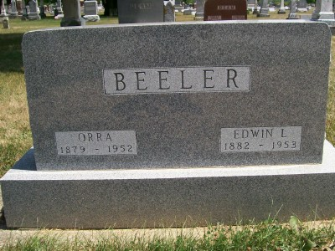
Photo by Scott Shoup

Indiana, Death Certificates, 1899-2011

Name: Edwin Lee Beeler (indexed as Edwin Lar Beelar)
Gender: Male
Race: White
Age: 70
Marital status: Married
Birth Date: 25 Oct 1882
Birth Place: Indiana
Death Date: 17 Mar 1953
Death Place: Rr3, Wells, Indiana, USA
Father: Daniel Beeler
Mother: Elizabeth Beeler
Informant: Mrs. Homer Schlagenhauf, Bluffton
Burial: 3-10-1953 Six Mile

