Orel Groden Baumgartner
May 2, 1895 – June 2, 1968

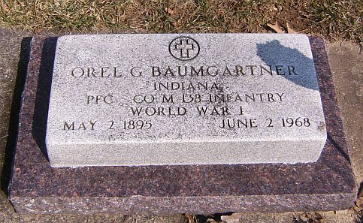
Photo by Scott Shoup

Indiana, Death Certificates, 1899-2011

Name: Oral G Baumgartner
Gender: Male
Race: White
Age: 73
Marital status: Never Mar
Birth Date: 2 May 1895
Birth Place: Indiana
Death Date: 2 Jun 1968
Death Place: Bluffton, Wells, Indiana, USA
Father: Jonathon Baumgartner
Mother: Eizabeth Meyer
Informant: Dewey Baumgartner, brother, RR Bluffton
Burial: Six Mile 6-5-1968

