Lillie May (Studabaker) Baumgartner
August 3, 1866 – November 23, 1947

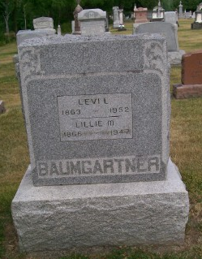
Photo by Scott Shoup

Indiana, Death Certificates, 1899-2011

Name: Lillie May Baumgartner
[Lillie May Studabaker]
Gender: Female
Race: White
Age: 81y 3m 20d
Marital status: Married
Birth Date: 3 Aug 1866
Birth Place: Wells Co, Indiana
Death Date: 23 Nov 1947
Death Place: Bluffton, Wells, Indiana, USA
Father: Abraham Studabaker
Mother: Louisa Dewitt
Spouse: Levi L Baumgartner, 84, informant
Burial: 11/26/1947 Six Mile Cemetery

