Della (Saurer) Baumgartner
November 10, 1902 – August 29, 1979

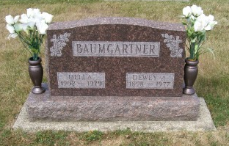
Photo by Scott Shoup

Indiana, Death Certificates, 1899-2011

Name: Della Baumgartner
[Della Saurer]
Gender: Female
Race: White
Age: 76
Marital status: Widowed
Birth Date: 10 Nov 1902
Birth Place: Indiana
Death Date: 29 Aug 1979
Death Place: Bluffton, Wells, Indiana, USA
Father: Albert Saurer
Mother: Anna Luginbill
Informant: Harold Baumgartner, Bluffton
Burial: Six Mile Sept. 1, 1979

