Phyllis Ann (Dulworth) Baublet
May 21, 1946 – August 21, 1969

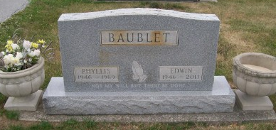
Photo by Scott Shoup

Indiana, Death Certificates, 1899-2011
Name: Phyllis Ann Baublet
[Phyllis Ann Dulworth]
Gender: Female
Race: White
Age: 23
Marital status: Married
Birth Date: 21 May 1946
Birth Place: Ind
Death Date: 21 Aug 1969
Death Place: Bluffton, Wells, Indiana, USA
Father: E J Dulworth
Mother: Lucille Vaughn
Spouse: Edwin C Baublet, informant
Burial: Six Mile 8-23-1969

