Marion (Reiff) Battin
May 14, 1923 – June 28, 1998

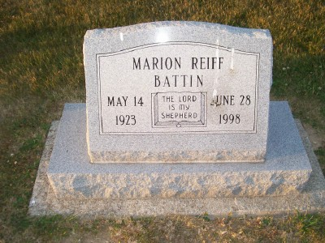
Photo by Scott Shoup

Indiana, Death Certificates, 1899-2011

Name: Marion Battin
Gender: Male
Race: White
Age: 75
Marital status: Divorced
Birth Date: 14 May 1923
Birth Place: Cedar Rapids, Iowa
Death Date: 28 Jun 1998
Death Place: Ft. Wayne, Allen, Indiana, USA
Father: Marion Reiff
Mother: Clara Luberger
Informant: Robert Hasinbiller, Fort Wayne, nephew
Cremation: July 4, 1998 Meeks Mortuary, Muncie, IN

