Frank Wilson Banter
January 28, 1885 – June 28, 1955

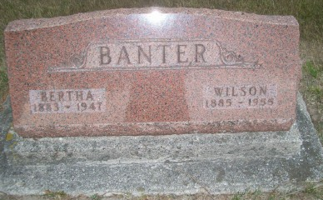
Photo by Scott Shoup

Wilson Banter, 70, Ex-Alexandrian, Dies in Berne

F. Wilson Banter, 70, former resident of Alexandria, died early this morning of a heart attack in Lynn Grove, Ind., near Berne.
Mr. Banter, born Jan. 28, 1885, was a 20 –year resident of Madison County. He was a retired farmer and hatchery operator. His wife died in Alexandria in 1947.
Surviving are one son, Norval Banter, Geneva; a daughter, Mrs. Walter Meyer, Geneva; brother, Everett Banter, Berne; and two grandchildren.
Funeral services will be held at 2 p.m. Thursday in the Yager Funeral Home, Berne, conducted by the Rev. George Holston, Kokomo. Burial will be in Bluffton Six-Mile Cemetery. Friends will be received at the Yager Funeral Home in Berne after 9 a.m. Wednesday.

Alexandria Times Tribune, Madison & Tipton Counties, Indiana
Tuesday, June 28, 1955

