Simon P. Baller
February 26, 1901 – July 23, 1978

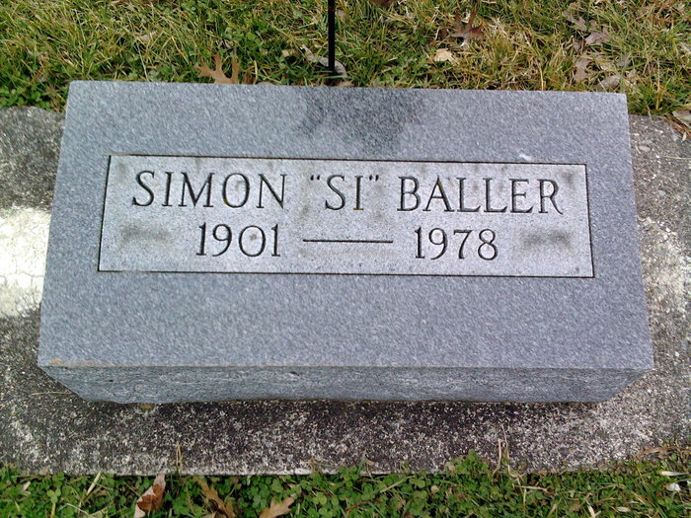
Photo by Scott Shoup

Indiana, Death Certificates, 1899-2011

Name: Simon P. Baller
Gender: Male
Race: White
Age: 77y 5m
Marital status: Divorced
Birth Date: 26 Feb 1901
Birth Place: Indiana
Death Date: 23 Jul 1978
Death Place: Bluffton, Wells, Indiana, USA
Father: John Baller
Mother: Emma Neuenschwander
Informant: Gale Baller, Bluffton
Burial: July 28, 1978 Six Mile Cem.

