Ruth Ann (Zook) Bailey
July 30, 1950 – June 3, 2021

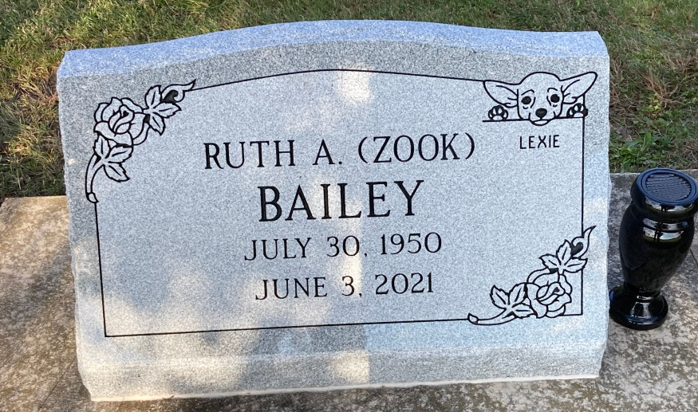
Photo by Scott Shoup

Ruth Ann Bailey, age 78, of Bluffton, died June 3, 2021 at her home. Mrs. Bailey was born in Bluffton, Indiana on July 30, 1950 to Mark and Betty Sook.
She is survived by her companion of 23 years, William Roughia of Bluffton; daughter, Luann and Kimball Black of Fort Wayne; son, Michael Studabaker of Bluffton; son-in-law, Daniel Brown of Bluffton; four grandchildren and three great grandchildren; three brothers, Kenny Sook, Ron Sook and Fred Sook all of Bluffton.
She was preceded in death by her parents, daughter, Melissa Brown in 2018 and brother, Mike Sook.
Private burial will take place later at Six Mile Cemetery.
Unknown source

