John R. Bailey Sr.
May 2, 1948 – January 24, 2017

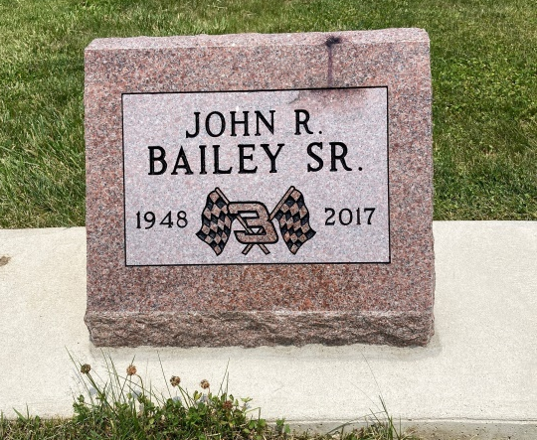
Photo by Scott Shoup

John R. Bailey, 68, of Poneto, IN, passed away at 9:18PM on Tuesday, January 24, 2017 at his residence in Poneto, IN. He was born on Sunday, May 02, 1948, in Owensville, KY. John attended Marion Schools. He served his country in the U.S. Marine Corps. He was a member of the United Methodist Church in Poneto, IN. John worked for Sterling Casting in Bluffton, IN for over 20 years. He retired from Red Gold in Geneva. He truly loved working. He was a member of the Moyer-Pooler American Legion. John enjoyed Nascar, gardening, and spending time with his grandchildren.
Loving Survivors Include: Fiance - Kathy Randall, Poneto, IN, Sons - Joe Bailey, Key West, FL, Shane Bailey, Bluffton, IN, John Bailey, Jr., Geneva, IN, Mike Randall, Poneto, IN, Alex Randall, Poneto, IN, Daughter - Rhiannon Randall, Geneva, IN, Brothers - Larry Bailey, Tom Bailey, Terry Egly, Jerry Egly, Randy Egly, Sister - Carolyn Egly, Granddaughter s- Paige Randall, Lindsey Randall, Grandsons - Ronnie Norman, Trevor Norman, Marcus Randall, and 1 Great Grandchild on the way.
He was preceded in death by his Father - Charlie Bailey, Mother - Ella (Toy) Egly, Sister - Betty J. Perry, Nephew- Chad Bailey, Brother - Chuck Bailey, and Brother - Carl Bailey.
Family and friends may gather to share and remember at Walker & Glancy Funeral Home 109 W. Windsor St. Montpelier, IN on Friday January 27, 2017 from 4:00PM to 8:00PM. A service to celebrate John’s life will be at Walker & Glancy Funeral Home at 11:00AM on Saturday January 28, 2017 with Roy Nevil officiating. Interment will follow in the Six Mile Cemetery in Bluffton. Military rites will be conducted by the U.S. Marines.
Preferred memorials: Family Life Care/NE Indiana Hospice 265 W. Water St. Berne In 46711. Arrangements are being handled by Walker & Glancy Funeral Home in Montpelier.

Walker & Glancy Funeral Home, Blackford County, Indiana
January 26, 2017

