Elmer Amburgey
September 3, 1925 – July 8, 2018

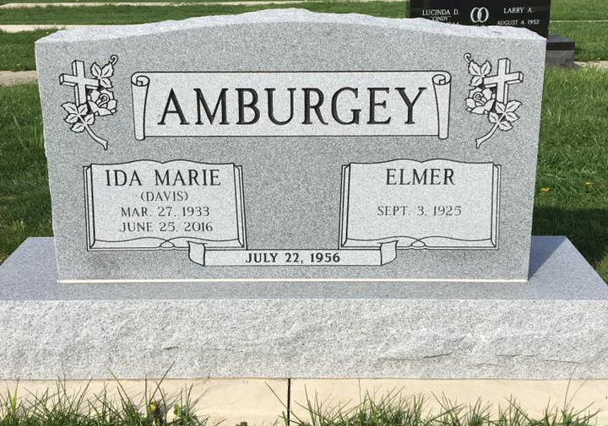
Photo by Scott Shoup

Elmer Amburgey, 92, of Uniondale passed away on Sunday evening, July 8, 2018, at Signature Health Care in Bluffton.
He was born on September 3, 1925 in Kentucky to Garland & Ada (Blair) Amburgey.
He married Ida M. (Davis) Amburgey, and she preceded him in death on June 25, 2016.
Elmer retired from International Harvester in Fort Wayne. He was an avid basketball fan and enjoyed collecting items.
Survivors include two children: Margaret Ann Woodward and Gary Amburgey, both of Bluffton along with two grandchildren: Josh Woodward and Jeremy Haus and a brother, Denver (Janet) Amburgey of Bluffton and many nieces and nephews.
Elmer is preceded in death by his parents and siblings; Winford Amburgey, Jewel Amburgey and Buford Amburgey.
Funeral services will be held at 11:00 A.M. on Thursday (July 12, 2018) at the Thoma/Rich, Lemler Funeral Home in Bluffton. Elder Ken Seymour will officiate. Calling Hours will be held from 4 to 8 P.M. on Wednesday at the funeral home and for one hour prior to the service. Burial will follow at Six Mile Cemetery in Bluffton. Memorials may be made in Elmer’s memory to Donor’s Choice. Funeral arrangements have been entrusted to the care of the Thoma/Rich, Lemler Funeral Home in Bluffton.
Thoma/Rich, Lemler Funeral Home, Wells County, Indiana
July 9, 2018

