Jimmy J. Allen
December 16, 1957 – April 23, 2016

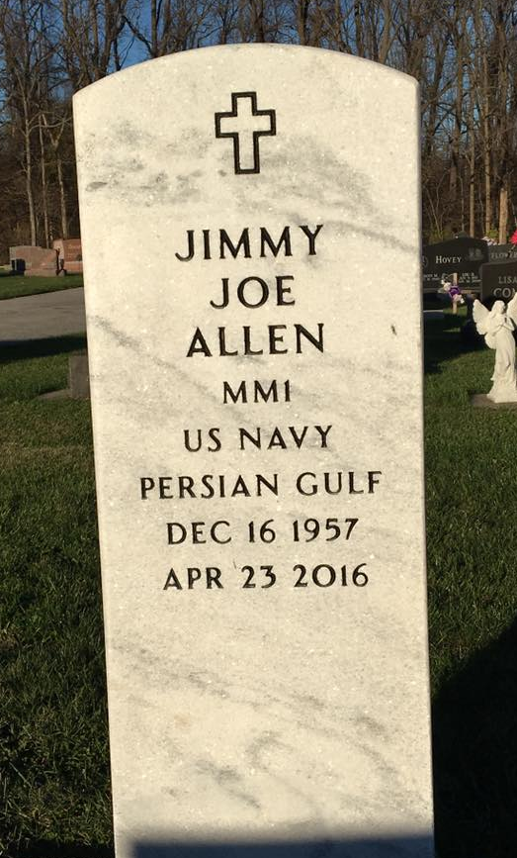
Photo by Scott Shoup

Jimmy J. Allen, 58, of Liberty Center, passed away at 10:35 a.m. on Saturday, April 23, 2016, at Signature Health & Rehabilitation Center in Bluffton.
He was born on December 16, 1957 in Muncie, Indiana to Jeff B. Allen and Helen D. (Pauley) Ford. He was a graduate of Bluffton High School and served during the Persian Gulf Wars and Operation Desert Storm in the United States Navy from 1975 to 1992 as was honorably discharged with the rank of E-6. He drove truck for Carter Express and also worked Gei-Corp in Markle. He was a member of the American Legion Post #111 of Bluffton. He enjoyed spending time outdoors, riding motorcycles, fishing and hunting.
Jimmy is survived by his mother Helen Ford of Bluffton along with children Wendy (Toby) Allen-Ward, B.J. Allen and Leisa Allen-McZegle all of Bluffton along with three grandchildren. He is also survived by siblings: Gayla (Mike) Grove of Liberty Center and Jack (Jennifer) Ford of Ossian, Jeff Michael (Kim) Allen of West Virginia, Rick (Gloria) Allen of Louisiana, Donna Emerick of Berne.
He is preceded in death by his father Jeff and step-father Jack Ford, Sr.
A service to celebrate Jimmy’s life will be held at 11 a.m. on Wednesday (April 27, 2016) at the Thoma/Rich, Lemler Funeral Home in Bluffton. Calling will take place from 9 to 11, prior to the service Wednesday. Burial will follow at Six Mile Cemetery in Bluffton with Military Honors by the American Legion Post #111 of Bluffton and the United State Navy Honor Guard. Memorials may be made to the family through the funeral home.

Thoma/Rich, Lemler Funeral Home, Wells County, Indiana
April 25, 2016

