William Perry Addington
May 10, 1881 – March 20, 1967

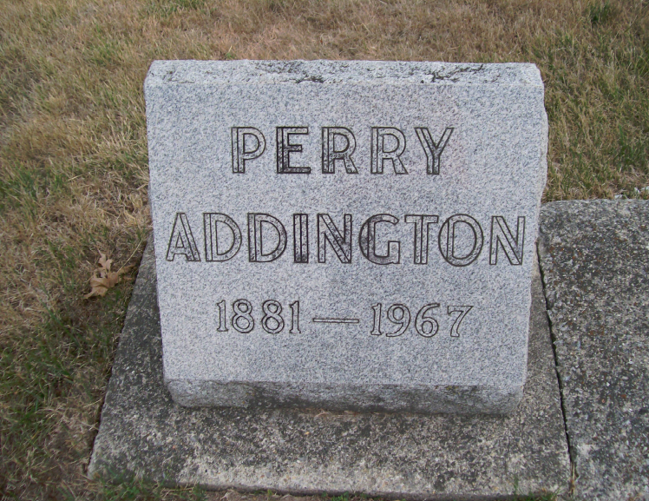
Photo by Scott Shoup

Indiana, Death Certificates, 1899-2011

Name: William Perry Addington
Gender: Male
Race: White
Age: 85y 10m 10d
Marital status: Never Married (Single)
Birth Date: 10 May 1881
Birth Place: Ind
Death Date: 20 Mar 1967
Death Place: Bluffton, Wells, Indiana, USA
Father: Pat Addington
Mother: Sarah Derting
Informant: Homer Addington, brother
Burial: 3-22-1967 Six Mile

