Irene Margaret (McCallie) Steiner
June 13, 1925 – July 10, 2002

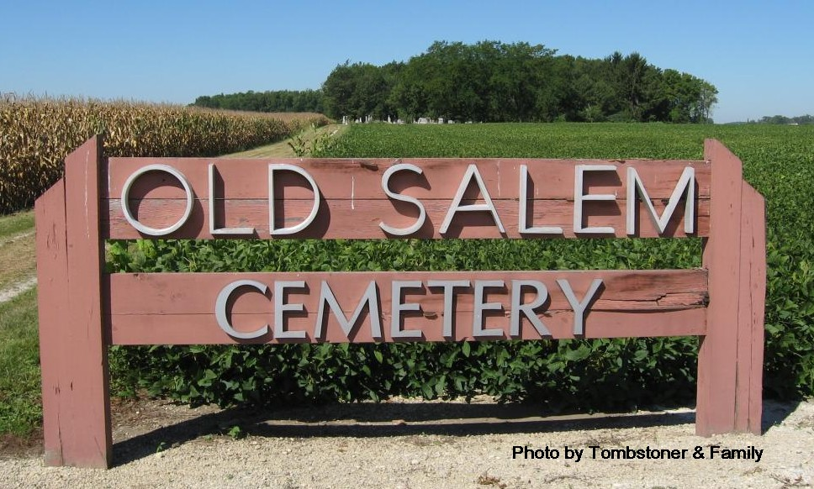
Obit from Jane Edson

Irene M. Steiner, 76, of Linn Grove, a member of Old Salem United Methodist Church, died Tuesday, July 10, 2001, at Chalet Village.
The Springfield, Ill., native was a bookkeeper. Surviving are her husband, Floyd; sons Ken of Monroe, George of Geneva and Karl of Domestic; daughters Judy Lynch of Bluffton and Barbara Renner of French Lick; stepsister, Beulah Rose Keller of Spencer; and 10 grandchildren. She was preceded in death by a grandson, Matthew.
Services are 10:30 a.m. Saturday at Old Salem United Methodist Church, Linn Grove, with calling from 2 to 8 p.m. Friday at Yager-Kirchhofer Funeral Home, Berne, and one hour before services at the church. Burial will be at Old Salem United Methodist Cemetery. Memorials are to Old Salem United Methodist Church.
Information provided by Yager-Kirchhofer Funeral Home, Berne, 1-219-589-3101.

News-Sentinel, Allen County, Indiana
Thursday, July 12, 2001

