Theodore E. Mason
July 11, 1908 - October 16, 1980

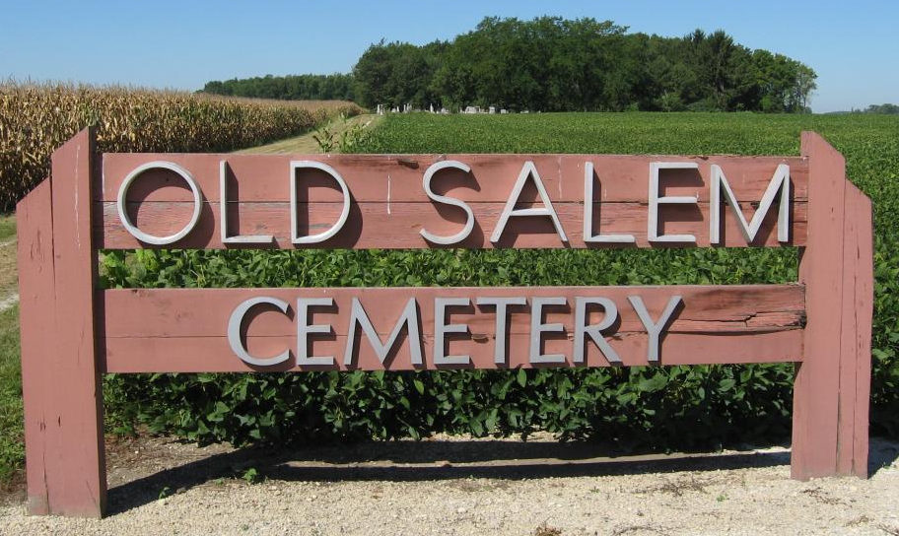
Photo by Tombstoner and Family
Obit from Elaine Geyer

Theodore E. (Ted) Mason, 72, Bluffton, a retired farmer and former employee of Berne Furniture Company where he had worked for 18 years, died at 2 am Thursday at Lutheran Hospital where he had been a patient since Tuesday.
A resident of Bluffton for the past 2 ½ years, he was a member of the Old Salem United Methodist Church.
Mr. Mason was a native of Adams County, born July 11, 1908, a son of John and Alda Woods-Mason and was married to Lillian Merillat, who survives on October 26, 1940, in Linn Grove.
Survivors include three daughters, Mrs. Robert (Janet) Stetler, Antwerp, O.; Mrs. John (Judy) Habegger, Linn Grove; and Miss Tami L. Mason, Fort Wayne; a son, Larry Mason, Route 1, Geneva; a sister, Mrs. Frances Biery, Geneva; two brothers, Edgar Mason, Springfield, O.; and John Mason, Berne; and five grandchildren.
Friends may call at the Thoma-Rich Funeral Home, Bluffton after 1 pm today. Services will be held at 2 pm Saturday at the funeral home by Rev. Gordon Neuenschwander with burial in Old Salem Cemetery.
Preferred memorials are to the American Cancer Society.

Newspaper clipping from the Florence Gause Collection
dated Friday, October 17, 1980

