Mary Anna (Osburn) Yoquelet
March 31, 1917 – October 19, 1992

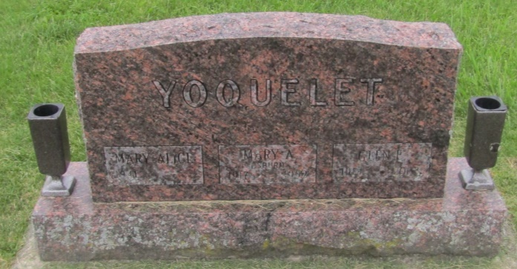

Mary Anna Yoquelet
in the Indiana, U.S., Death Certificates, 1899-2011
Name: Mary Anna Yoquelet
[Mary Anna Osburn]
Gender: Female
Race: White
Age: 75
Marital status: Married
Birth Date: 31 Mar 1917
Birth Place: Wells County, Indiana
Death Date: 19 Oct 1992
Death Place: Markle, Wells, Indiana, USA
Father: Willis Osburn
Mother: Mary Ethel Ertel
Spouse: Glen E Yoquelet
Informant: Glen E. Yoquelet; husband; Markle, Indiana
Burial: October 21, 1992; Prospect Cemetery; Wells County, Indiana

