Glen E. Yoquelet
April 4, 1914 – December 26, 2003

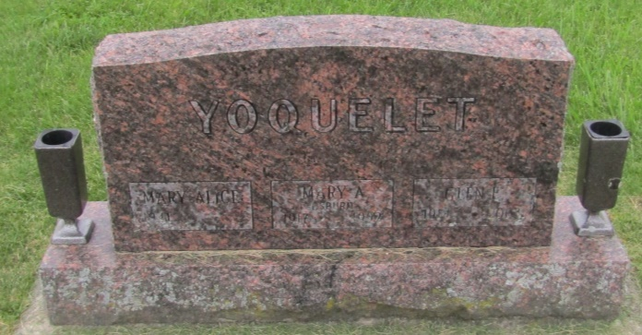

Glen E. Yoquelet, 89, of rural Markle, died this morning, Dec. 26.
Born Apr. 4, 1914 in Huntington County, he resided the past several years in Rockcreek Township in Wells County.
Survivors include a daughter, Mary Alice Yoquelet, at home; two sons, Eugene E. Yoquelet of Ossian and Bobby G. Yoquelet of Howe; three granddaughters; a sister and a brother.
He was preceded in death by his wife, Mary, in 1992.
Visitation hours will be Monday from 9 to 11:30 a.m. at the Elzey Patterson Rodak Funeral Home in Ossian, which will be followed by a graveside committal service at Prospect Cemetery.

Elzey Funeral Home, Wells County, Indiana
December 27, 2003

*****
Indiana, U.S., Death Certificates, 1899-2011
Name: Glen E Yoquelet
Gender: Male
Race: Caucasian (White)
Age: 89
Marital status: Widowed
Birth Date: 4 Apr 1914
Birth Place: Whitley County, Indiana
Death Date: 26 Dec 2003
Death Place: Bluffton, Wells, Indiana, USA
Father: George Yoquelet
Mother: Lydia Fulmer
Informant: Eugene Yoquelet; son; Ossian, Indiana
Burial: December 29, 2003; Prospect Cemetery; Ossian, Indiana

