Elizabeth “Eliza” (Wilcox) Wolfcale
December 2, 1807 – October 17, 1887

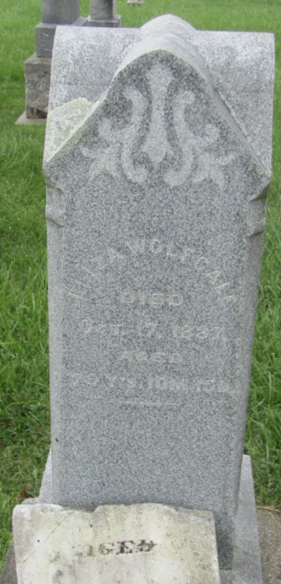

Elizabeth Wilcox from tree Coffey/Wolfcale family tree
Birth 2 Dec 1807 Maryland, USA
Marriage 28 Feb 1828 Trumbull, Ashtabula, Ohio, USA
Residence 1880 Wells, Indiana, USA
Death 17 Oct 1887 Wells, Indiana, USA
Father John Wilcox (1780-1873)
Mother Sarah Farris (1779-1863)
Spouse Abraham Wolfcale (1806-1874)

