Charles A. Wilson
September 14, 1894 – November 20, 1964

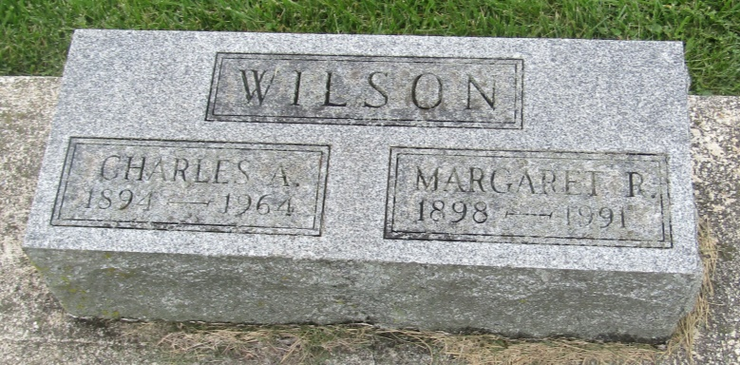

Charles A Wilson
in the Indiana, U.S., Death Certificates, 1899-2011
Name: Charles A Wilson
Gender: Male
Race: White
Age: 70
Marital status: Married
Birth Date: 14 Sep 1894
Birth Place: Wells County Ind
Death Date: 20 Nov 1964
Death Place: Wells, Indiana, USA
Father: James S Wilson
Mother: Janete VanWorner
Informant: Margaret Wilson; wife; Markle, Indiana
Burial: November 23, 1964; Prospect Cemetery; Wells County, Indiana

