Babe Letheta (Eichhorn) Wilson
October 24, 1933 – May 5, 1995

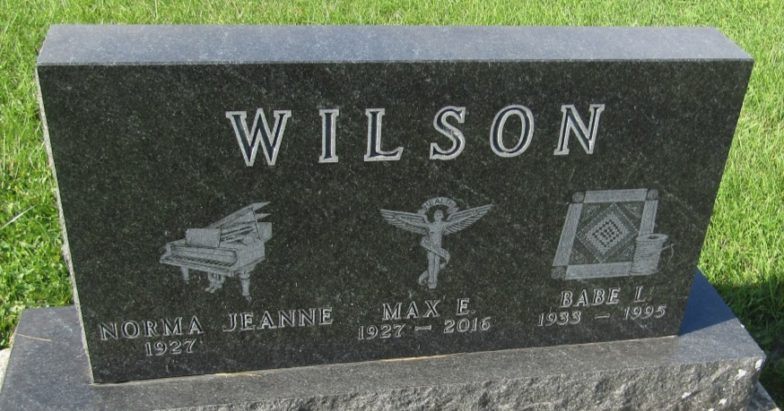

Babe Letheta Wilson
in the Indiana, U.S., Death Certificates, 1899-2011
Name: Babe Letheta Wilson
[Babe Letheta Eichhorn]
Gender: Female
Race: White
Age: 61
Marital status: Married
Birth Date: 24 Oct 1933
Birth Place: Wells County In
Death Date: 5 May 1995
Death Place: Ft Wayne, Allen, Indiana, USA
Father: Don Eichhorn
Mother: Letheta Breckbill
Spouse: Max E Wilson
Informant: Max E. Wilson; husband; Artesia, New Mexico
Burial: May 9, 1995; Prospect Cemetery; Wells County, Indiana

