Catherine Elizabeth “Ormsby” Williams
December 17, 1935 – December 19, 2019

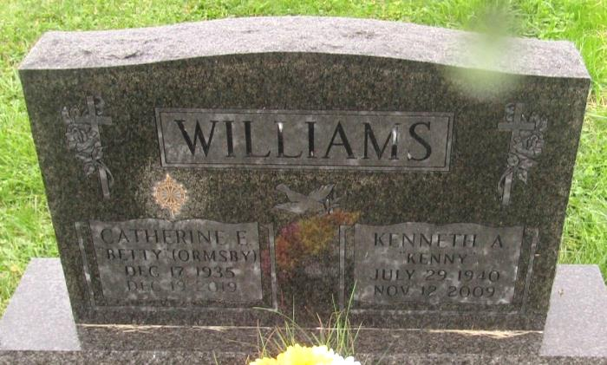

Catherine Elizabeth “Betty” Williams, 84, passed away peacefully into the arms of the Lord on Thursday, December 19, 2019. She was the daughter of the late Argus Luster and Edna Chloe (Mann) Ormsby. Betty was born on December 17, 1935, in Darke County, Ohio.
She was baptized in April of 1952 at St. John’s Evangelical Lutheran Church, alongside her sisters and mother, and was a graduate of South Side High School in 1954. She retired from Verizon, and was an active member of Emanuel Lutheran Church, New Haven. She was an active member of DAR - The Colonel De La Balme Chapter, Columbia City, Moose Lodge 1480, American Legion Post 330 and VFW Post 2457 all of New Haven.
Betty cherished the time spent with her loved ones and was most proud of the large family she created. She enjoyed spending time in her garden, loved feeding her birds, and catching up with friends over weekly rounds of euchre. Betty lived a very full and blessed life and embraced every moment she had. She taught her family many things, except how to grow old.
She is survived by her children, Jerry (Connie) Wilson, Cathy (Gary) Platt, Cindy (Kent) Hesterman, Lisa Kay Samra, Lori (Chris) Fisher, and Melissa (Ben) Koeneman; 13 grandchildren; 11 great grandchildren; and her sisters, Judith Elaine Richter, and Nancy Lou Henninger, and dear friend Cal Derkson.
She was also preceded in death by her husband, Kenneth Alan Williams; and son, Steven Robert Wilson.
Funeral service is 1:30 p.m. Monday at Emanuel Lutheran Church, 800 Green St, New Haven visitation three hours prior; Pastor Paul Shoemaker officiating; Burial in Prospect Cemetery, Ossian.

Harper’s Funeral Home, Allen County, Indiana
December 21, 2019

