Peter F. Wickliffe
June 5, 1850 – March 19, 1930

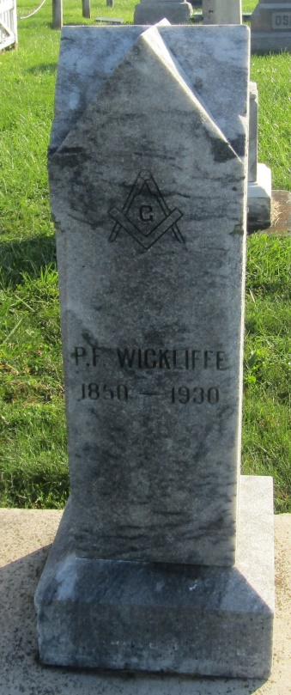

CARPENTER DIES AT MURRAY

Peter F. Wickliffe, 70, died at the home of Mrs. Newton Davis at Murray at 10:30 o'clock last night, following an illness of four weeks, of kidney trouble and complications.
He was a carpenter and was a resident of Wells County thirty-five years and resided for a number of years at Ossian.
Surviving are two sons, Ora, of Fort Wayne, and Dell, near Ossian; and three daughters, Mrs. Minnie Hoot, Warren, O., Mrs. Nathaniel Prough, of near Ossian and Mrs. Golda Pangborn, Warren, O. Brothers and sisters living are Branson and Martin Weaver, Fort Wayne; Frank, near Yoder; Mrs. Uriah Mast, Uniondale; and Mrs. Jasper Middaugh, west of Ossian.
Funeral services will be held at the Prospect M. E. Church at 2 o'clock Saturday afternoon. Burial will be at Prospect Cemetery.

The Star Press; Grant County, Indiana
Friday, March 21, 1930

*****
Indiana, U.S., Death Certificates, 1899-2011
Name: Peter F. Wickliffe
Gender: Male
Race: White
Age: 79
Marital status: Widowed
Birth Date: 5 Jun 1850
Birth Place: Ohio
Death Date: 19 Mar 1930
Death Place: Murray, Wells, Indiana, USA
Father: Frank Wickliffe
Mother: Rebecca Fritz
Spouse: Nancy
Informant: Dell B. Wickliffe; Ossian, Indiana
Burial: March 22, 1930; Prospect Cemetery

