John Franklin Wasson
April 20, 1884 – February 19, 1931

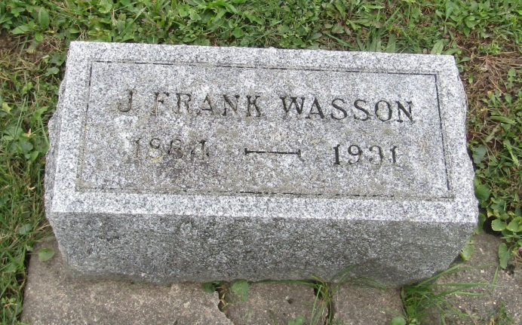

Jomar Wasson
in the Indiana, U.S., Death Certificates, 1899-2011
Name: J. Frank Wasson
Gender: Male
Race: White
Age: 46
Marital status: Married
Birth Date: 20 Apr 1884
Birth Place: Indiana
Death Date: 19 Feb 1931
Death Place: Fort Wayne, Allen, Indiana, USA
Father: David T. Wasson
Mother: A Young Fleming
Spouse: Jennie
Informant: Mrs. Jennie Wasson
Burial: February 21, 1931; Prospect Cemetery; Prospect, Indiana

