Edna M. (Pressler) Veazey
September 8, 1907 – January 28, 1994

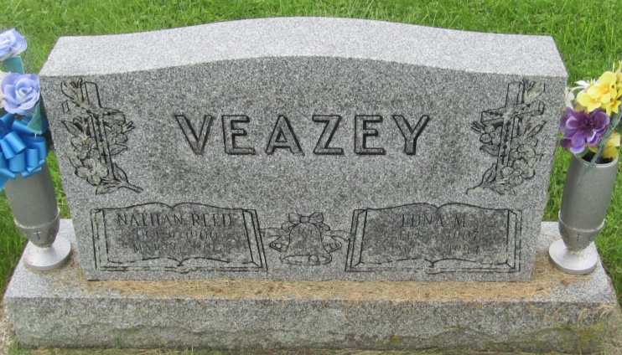

Edna N Veazey
in the Indiana, U.S., Death Certificates, 1899-2011
Name: Edna N Veazey
[Edna N Pressler]
Gender: Female
Race: White
Age: 86
Marital status: Married
Birth Date: 8 Sep 1907
Birth Place: Albion, Indiana
Death Date: 28 Jan 1994
Death Place: Ossian, Wells, Indiana, USA
Father: Harvey P Pressler
Mother: Vadus Schlotterback
Spouse: Nathan Reed Veazey
Informant: Phyllis J. Folk; daughter; New Haven, Indiana
Burial: February 1, 1994; Prospect Cemetery; Wells County, Indiana

