Leo Robert Trim
March 6, 1922 – May 8, 2005

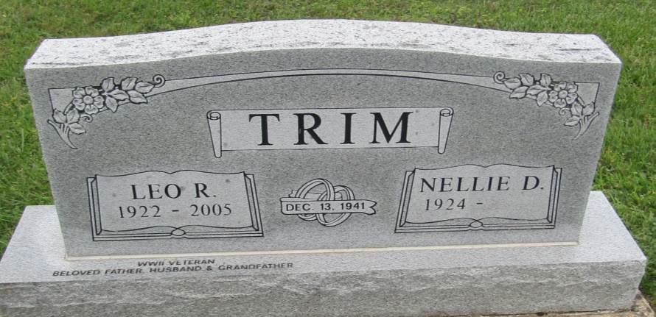

Leo Robert Trim, of Fort Wayne, died Sunday, May 8, 2005, 8 a.m., of natural causes due to a heart attack complicated by the end state of Parkinson's disease. He was a strong-willed man who carved a life for himself and his family after returning from World War II as a Purple Heart veteran.
Born March 6, 1922, in Fort Wayne he was the son of Frank and Katie Trim. Drafted in 1941, he led a twelve man rifle unit through France and Germany, serving his country until his honorable discharge, in 1944. After the war, he worked for the Pennsylvania Railroad while taking courses in electrical technology.
As resourceful as he was stubborn, he worked his way into a better life, educating himself until his retirement as head electrician for International Harvester, in 1980. "Grandpa" and/or "Dad" will be remembered for building and flying model airplanes when his sons were young, fixing up old cars, operating HAM radios as WD9ACF, and for teaching his granddaughter to be independent, even when it came to working on her own car. His creative and intelligent solutions to problems both mechanical and electrical were well regarded by his family, friends and co-workers. "Leo was honest, trustworthy, and good hearted. He will be sorely missed."
Surviving are his wife of 63+ years, Nellie; his sisters, Flora Mae and Eddice; his sons, Neil and David; and his five grandchildren, Michelle, Robert, Jim, Kimberly and Chrissie.
Calling is from 2 to 4 p.m. today at C.M. Sloan & Sons Funeral Home, 1327 Wells St. Graveside service is 10 a.m. Wednesday at Prospect Cemetery, Ossian.

Fort Wayne Newspapers, Allen County, Indiana
May 10, 2005

*****
Indiana, U.S., Death Certificates, 1899-2011
Name: Leo R Trim
Gender: Male
Race: White
Age: 83
Marital status: Married
Birth Date: 6 Mar 1922
Birth Place: Fort Wayne, In
Death Date: 8 May 2005
Death Place: Fort Wayne, Allen, Indiana, USA
Father: Frank Trim
Mother: Katie Reader
Spouse: Nellie Prough
Informant: Nellie Trim; wife; Fort Wayne, Indiana
Burial: May 11, 2005; Prospect Cemetery; Ossian, Indiana

