David A. Trim
February 27, 1951 – December 14, 2006

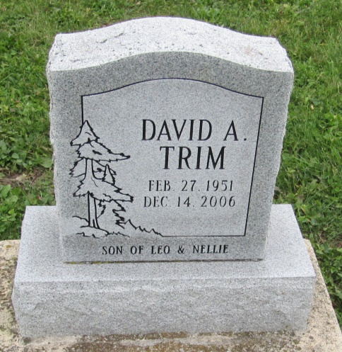

David Trim, 55, of Fort Wayne, died Thursday, Dec. 14, 2006.
Surviving are his brother, Neil; and three children, Kimberly, Christine and James.
Arrangements by C.M. Sloan & Sons Funeral Home, 1327 Wells St.

Fort Wayne Newspapers, Allen County, Indiana
December 16, 2006

*****
Indiana, U.S., Death Certificates, 1899-2011
Name: David Trim
Gender: Male
Race: White
Age: 55
Marital status: Divorced
Birth Date: 27 Feb 1951
Birth Place: Fort Wayne, In
Death Date: 14 Dec 2006
Death Place: Fort Wayne, Allen, Indiana, USA
Father: Leo Trim
Mother: Nellie
Informant: Michelle Trim; daughter; Greenwood, South Carolina
Burial: December 20, 2006; Prospect Cemetery; Ossian, Indiana

