Uriah Todd
August 5, 1838 – November 26, 1867

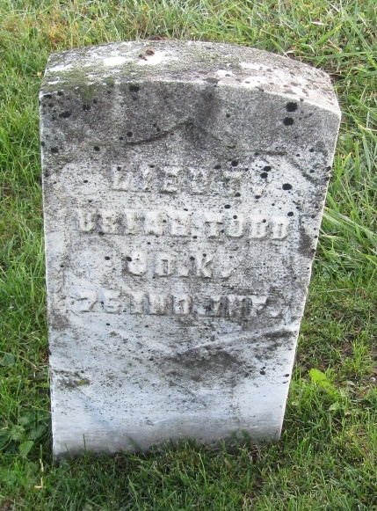

MASONIC OBITUARY
Died at Middletown, Allen County, Indiana, April 14, 1880, Brother Uriah Todd.
(Fraternal oaths)
Fort Wayne Daily Gazette; Allen County, Indiana
April 26, 1880
*****
U.S. Civil War Soldier Records and Profiles
Name: Uriah Todd
Residence: Indiana
Enlistment Date: 8 Aug 1862
Rank at enlistment: 2nd Lieutenant
State Served: Indiana
Survived the War?: Yes
Service Record: Commissioned an officer in Company K, Indiana 75th Infantry Regiment on 19 Aug 1862.
Transferred out of Company K, 75th Infantry Regiment Indiana.
Sources: American Civil War Soldiers
*****
Uriah Todd from tree Deb's Family Tree...one relative at a time
Birth 5 Aug 1838 Beaver City, Beaver, Pennsylvania, USA
Residence 1866 Indiana, USA
Marriage 26 Nov 1867 Fort Wayne, Allen, Indiana, USA
Death 14 Apr 1880 Middletown, Henry, Indiana, USA
Father Jacob Jefferson Todd (1805-1861)
Mother Jane Thomas (1807-1888)
Spouse Louisa "Lois" Smitley (Todd) (1847-1904)

