Martha A. (Quackenbush) Templeton
March 19, 1830 – July 13, 1904

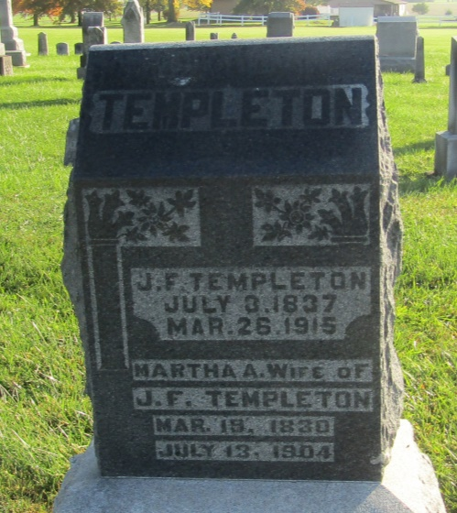

Mertha A Templeton
in the Indiana, U.S., Death Certificates, 1899-2011
Name: Martha A Templeton
[Martha A Quackenbush]
Gender: Female
Race: White
Age: 74
Marital status: Married
Birth Date: 19 Mar 1830
Birth Place: New York
Death Date: 13 Jul 1904
Death Place: Bluffton, Wells, Indiana, USA
Father: Wm Quackenbush
Mother: Mary Allen
Spouse: Jno F Templeton
Informant: Harry Deam; Bluffton, Indiana
Burial: July 15, 1904; Prospect Cemetery

