Oliver Taylor
- October 5, 1854

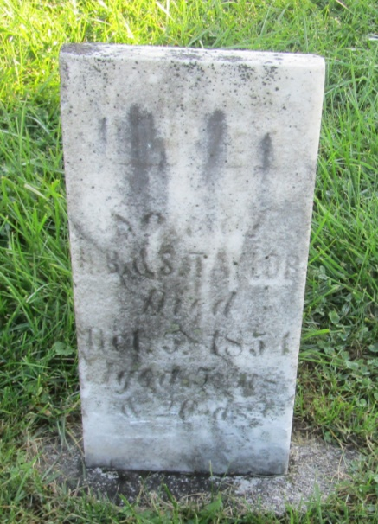

No further information found at this time

