Infant Twin daughter Stump
June 16, 1904 – June 16, 1904

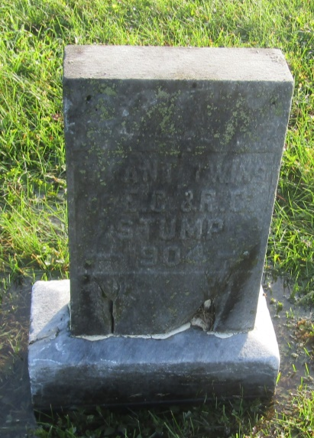

Not Named Stump
in the Indiana, U.S., Death Certificates, 1899-2011

Record #: 245 - 119
Name: Not Named Stump
Gender: Female
Race: White
Age: 0
Marital status: Single
Birth Date: 16 Jun 1904
Birth Place: Wells Co Ind
Death Date: 16 Jun 1904; stillborn
Death Place: Ossian, Wells, Indiana, USA
Father: Elcie E Stump
Mother: Rillie Bowersock
Informant: not names
Burial: June 17, 1904; Prospect Cemetery

